Times Tables Games
Games and are a great way to support learning, and a few minutes a day will make all the difference. Using games keeps practice short and sweet, and makes the process much less of a chore for you and your child. There are loads of games available on the internet, but here are just a few to get you started:

KABOOM
Number of Players: 2 or more

Resources: Strips of card, cup or envelope.
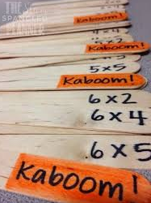

Setting up the game:
1.Write times tables on different strip of card
2.Include 3 strips with the word KABOOM written on them
3.Place strips in a cup

How to play:
1. Take it in turns to pull a stick/strip
2. Answer correctly……keep your stick.
3. Miss it...return the stick. Discuss how you could have solved the sum
4. Keep taking turns until......
5. Someone draws a KABOOM! All the player's sticks go back in the cup but keep out the KABOOM stick.
6. Winner is the player with the most sticks.

Making is easier:
Focus on multiplication facts for one times table at a time.
Making it harder:
Include division sum
Include a mix of multiplication sums.
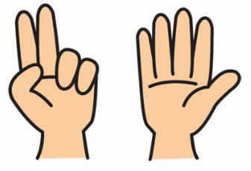

FINGERS
Number of Players: 2

Resources: Pen and Paper
.
How to play:
- Players count to 3 and then show a certain number of fingers.
- Players then multiply these 2 numbers together. For example, if player 1 shows 3 fingers and player 2 shows 6 fingers, they would calculate 3 x6.
- The first player to shout out the answer writes a letter from the word ‘FINGERS’.
- The first player to spell FINGERS is the winner.

Making it easier:
- Each player only uses one hand and adds together the total number of fingers. Players then have to multiply this number by the times table they are practising. For example, player 1 shows 3 fingers and player 2 shows 4 fingers. The players add together 3 and 4 to make 7. They then calculate 7 x (whichever time stable they are practising).

MULTIPLICATION MONSTERS

Number of players: 2 or more
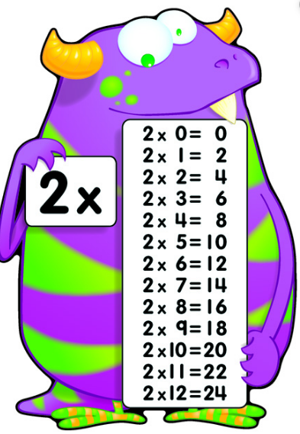

Resources: Multiplication Monster Cards or small squares of card

Setting up the game:
- Write a times table sum on each of the cards. You can either focus on the times tables you are currently learning or recap all previously learnt tables.
- Spread out the cards and lay face-down.

How to play:
- Both players turn over a card and calculate the answer.
- The player who has the larger number gets to keep both cards.
- The player with the most cards at the end of the game is the winner.
Making it harder: Include both division and multiplication facts.

MULTIPIGATION

Number of players: 2


Resources: 2 dices, pen and paper

How to play:
- Choose which times table you wish to practise (for example, x5)
- Roll the dice to see who starts
- Player 1 roll the dice twice and adds the numbers together (For example, 5+ 3 = 8)
- Player 1 then multiplies these number by their chosen times table (for example, 8 x 5 = 40)
- Player 1 may then wish to BANK their money or roll again. However, if you choose to roll again and roll a 1 then you will lose your current score. Your score is then recorded as 0, or a pig! Once you have BANKED your money, your turn is over. BANKED money can never be lost.
- The winner is this first player to 100/500 – you can decide depending on which tables you are working on.
Or the winner is the player to have banked the most money after 5 goes each.

Making it harder: Practise all your tables by rolling the dice 4 times. 2 times to generate the first number, and another 2 times to generate the second number

Useful Websites

- https://www.topmarks.co.uk/maths-games/hit-the-button
- https://www.timestables.co.uk/games/
- https://www.timestables.co.uk/speed-test/

